PREMIUM LIST
Friday, August 21 Event #2026043525 Friday, August 21 Event #2026043526
Saturday, August 22 Event #2026043527 Saturday, August 22 Event #202643529
Sunday, August 23 Event #2026043528 Sunday, August 23 Event #2026043530

Oshkosh Kennel Club AKC Fast Coursing Ability Test
All-Breed and All American (Mixed Breed Dogs)

August 21-23, 2026

(Licensed by the American Kennel Club)

EVENT LOCATION

Oshkosh Kennel Club

220 W Packer Avenue, Oshkosh, Wisconsin 54901
Test Hours: Check in starting at 7:30 am
Day of Entry check in must be by 2
pm Visual Inspections done just prior to run time Runs begin at 8 am until all runs are completed
First Come – First Served

Each test limited to 150 entries per event
Pre-Entry is strongly encouraged

Day of event entries accepted as space allows Tests will run concurrently each day
Entries open June 30, 2026 PRE-ENTRIES CLOSE AT NOON WEDNESDAY, August 14, 2026 at the Trial Secretary’s address or when numerical limits are reached if before August 14, 2026. Late entries will be accepted with a late entry fee of $5.00 per entry per event if numerical limits have not been reached by Pre-Entry closing date.

Permission has been granted by the American Kennel Club for the holding of this event under American Kennel Club Rules & Regulations.

OKC INC. CLUB OFFICERS
President: Denice Van Hook Vice President: Tammy Horton
Corresponding Secretary: Barb Waltenberry Treasurer: Marian Fenlon
Recording Secretary: Kandi Beaver
Board Members: Cindy Bohnert, Mark Besaw, Paula Hohol, Jaci Fredricks

FAST CAT CHAIR
Pete Pischke, 1287 Valley Road, Oshkosh, WI 54904 (920) 479-8592 cima721@gmail.com

FAST CAT SECRETARY
Cindy Pischke, 1287 Valley Road, Oshkosh, WI 54904 (920) 233-8128 cima721@gmail.com

FAST CAT COMMITTEE MEMBERS
Pete Pischke, Cindy Pischke, Marianne Ronson, Gabe Marquart, Tammy Horton

LURE OPERATOR
Don Adams – Fast and Fun

Directions to the show: From the North or South: Hwy 41 to Hwy 76 Exit Hwy 76/Jackson Street towards Oshkosh, 3.1 miles. Turn left on Packer Avenue to the OKC Clubhouse. Or Hwy 41 to Hwy 45 (Algoma Blvd) toward Oshkosh to Murdock Av, turn left on Murdock Ave to Jackson, turn left on Jackson to Packer Ave, right on Packer. – Parking in OKC lots only – NO parking allowed on street or in Oshkosh Auto Works next door. No overnight parking allowed on blacktop lot. RV or overnight parking permitted on gravel parking lot only. Cost for RV & overnight parking is $10 per night no hookups

MOTELS
The following motels have accepted well-mannered dogs. Please be sure to verify:
LA QUINTA -1886 Rath Lane, Oshkosh, WI 54902 (920)233-4190 (Hwy 41 & 21)
HOLIDAY INN – 2251 Westowne, Oshkosh, WI 54904 (Hwy 41 & 21) (920)303-1300 COBBLESTONE INN – 3105 S. Washburn St. Oshkosh, WI 54904 (920)303-1133
BAYMONT – 1581 W. South Park, Oshkosh, WI 54904 (920)240-8264
FAIRFIELD INN – 1800 S. Koeller St. Oshkosh, WI 54902 (920)233-8504
AMERICINN— 1515 Planeview Drive, Oshkosh (Hwy 41 & 26) 920-376-8729

****VETERINARIAN ON CALL****
Fox Valley Animal Referral / BluePearl —4706 New Horizons Blvd—Appleton 920-993-9193

PRIZES AND ROSETTES

Qualifying Run - flat blue ribbon BCAT - 24” triple streamer rosette DCAT - 30” triple streamer rosette
FCAT & Above - 36” triple streamer rosette
A special Commemorative ribbon tag with your dog’s name and title will be awarded to all dogs earning a new title.
EMBROIDERED CHAIR – TO WIN, RECEIVE 1 TICKET FOR EACH RUN FOR DRAWING TO BE HELD ON SUNDAY AFTERNOON
If you complete a title at this event, please notify the Fast CAT Secretary.

ENTRY FEE
$25.00 pre-entry per dog per test (Includes $4.50 AKC recording fee)
There will be a $25.00 service charge for any returned check
Day of test entries are $30.00 for each entry. Day of test entries accepted as space allows. Entries received after the closing date of August 14, 2026 will be charged a $5.00 Late Entry fee per event. If the trial has not filled, day of show entries will be accepted up to noon for each day’s respective trial and dogs not registered by that time will be considered absent. Incomplete, unsigned, or conditional entries will not be accepted. Entries will be acknowledged by email if legible email address is provided in the entry form.

Make checks payable to:
Oshkosh Kennel Club, Inc.

Please mail to:

Fast CAT Secretary
1287 Valley Road, Oshkosh, WI 54904

Or you can enter on line at the following link:
https://pci.jotform.com/form/261596339032157
*A $2.00 convenience fee will be charged for on line entries

CONDITIONS OF ENTRY
All dogs must have an AKC registration number and be at least one year of age on the day of the trial. Dogs may only run once per test. All entries must be accompanied with a Check payable to Oshkosh Kennel Club, Inc. to be valid. Entries received by phone, text or email will not be accepted. Incomplete entries or forms without a signature will not be accepted.
Fast CAT events are open to all dogs at least 12 months of age that are individually registered with the AKC, recorded in the Foundation Stock Service (FSS) program, individually registered with the foreign or domestic registry organization whose pedigrees are acceptable for AKC registration, dogs granted a Purebred Alternative Listing (PAL) number, dogs with AKC Limited or Conditional Registration, or dogs enrolled in the AKC Canine Partners Program. Dogs with breed disqualifications and monorchid/cryptorchid Dogs are eligible to participate.

WHAT IS FAST CAT
Fast CAT (Fast Coursing Ability Test) is a timed straight 100-yard dash for dogs. Dogs are held at the start line and the coursing lure is activated prompting the dog to follow chasing it to the finish line and into a catch pen. The course is completely fenced and dogs are run individually. Dogs are timed when they complete the 100-yard dash. The time is converted to miles per hour (MPH).
FORMULA: 204.545 / RUN TIME = MPH
MPH X HANDICAP = POINTS (Rounded to the nearest 0.01 MPH)
A dog’s handicap is determined by the height of the dog at the withers, a handicap is applied and points are earned.
18” or greater = Handicap multiplier - 1.0 12” to 18” = Handicap multiplier - 1.5 12”and below= Handicap multiplier - 2.0
Titles are earned at specific point levels and the highest suffix may appear after the dog’s name:
BCAT = 150 points DCAT = 500 points FCAT = 1000 points FCAT2 = 1500 points
FCAT#... For each additional 500 points

Coursing is an athletic activity that can tax a dog’s physical strength. Dogs that are overweight and/or out of condition may be at greater risk for injury and exhaustion. The Inspection committee has the authority to disallow a dog’s entry into a test. At roll call, all dogs will be measured by a wicket to verify handicaps. Bitches in season with either a visual inspection or a letter from a vet will receive entry refund. Lame and unfit dogs will be excused without entry refunded.
Please do not bring bitches in season to the test!

TOP 20 BY BREED BY YEAR
The AKC fast cat website will feature the top 20 fastest dogs by breed by year national standings. The standings will be updated as event results are processed at https://www.apps.akc.org/apps/fastcat ranking

HOURS
Check in will begin no later than 7:30 AM. Visual inspections will be done prior to run time. It is the responsibility of each entrant to make an effort to be ready when their dog is called to the line. The runs begin at 8 AM until all runs are completed. For the safety of our volunteers and participants, lightning is the only reason to cause the postponement and or cancellation of an event.

OKC FAST CAT INFORMATION
- ALL DOGS RUN AT OWNER’S SOLE RISK
- All dogs must be 12 months of age or older on the day of the test.
- All dogs must be leashed on trial property. No electronic or prong collars permitted on trial grounds.
- Title winners should report to the Field Secretary who will award you your ribbons.
- Should the trial be cancelled due to COVID regulations Oshkosh Kennel club will shred all checks
- All AKC rules regarding sportsmanship and conduct apply.
- This is it rain or shine outdoor event. Please plan accordingly. Please bring your own shade, chairs and water.
- The grounds are not completely fenced.
- The Fast CAT course is completely fenced.
- Bathrooms will be available.
- All dogs must be on a lead or created unless running.
- Owners are expected to clean up after their dogs.
- Each dog requires an individual entry form.
- You’re responsible for controlling your dog or dogs and children.
- Bitches in season and lame dogs will be excused.
- Bitches in season and injured dogs will receive a refund by presenting to the field secretary prior to the start of the first trial of the weekend, a veterinary certificate stating they are unable to compete.
- The field committee is responsible for field safety and therefore in complete charge of all dogs and handlers on the field. In service to this responsibility, they have the authority to stop the lure in any potentially dangerous situation and signal the handler to retrieve the dog on the course.
- Dogs and or persons exhibiting conduct detrimental to OKC/AKC will be asked to leave the trial site by the field committee and may be disciplined by the AKC. Entry fees will not be refunded.
- Fees shall not be refunded in the event a dog is absent. No entry fees will be refunded if the event cannot be started or completed by reason of riots, civil disturbances, fire, extreme and/or dangerous weather conditions, acts of God, public emergency, act of a public enemy, strikes or any other causes beyond the control of OKC.
- The event hosting club, Oshkosh Kennel Club, its agents, members, representatives, volunteers, etc., assume no liability or responsibility for any loss, damages or injuries sustained by exhibitors, handler’s, or to any of their dogs or property and further assumes no responsibility for injury to children or spectators before, during, or after this event.
- These tests will run concurrently.
- For dogs running in both events on the same day, they must be inspected prior to each run.
- If doing a day of entry, check in must be by noon each day.

Reserve theses dates for upcoming shows and trials

Obedience and Rally Trials
September 11-13, 2026
October 24-25, 2026

Agility Trials
October 17-19, 2026
October 31 - November 2, 2026

See website for more information
www.oshkoshkennelclub.com
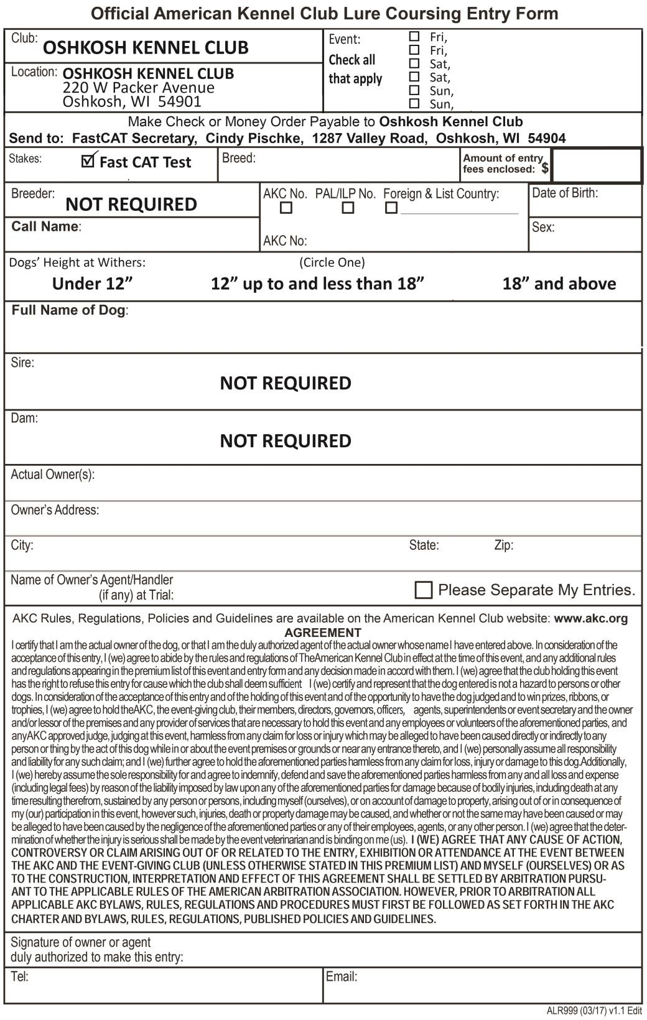
FAST CAT SECRETARY
Cindy Pischke 1287 Valley Road
Oshkosh, WI 54904
Aug 21 Event #2026043525
Aug 21 Event #2026043526
Aug 22 Event #2026043527
Aug 22 Event #2026043529
Aug 23 Event #2026043528
Aug 23 Event #2026043530

